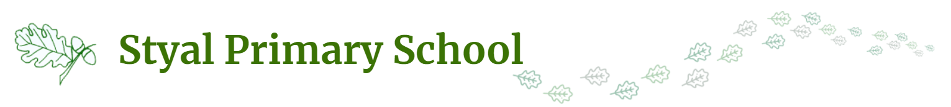Year 5 and Year 6 Pupils - Acceptable Use Agreement
  My Learning | - I will use school devices (PCs, laptops, tablets/ ipads) for my learning.  - I will ask a teacher before using a device and ask for help if I can’t work the device.  - I will only use activities that a teacher has told or allowed me to use.  - I will ask a teacher if I am not sure what to do or I think I have done something wrong.  - I will look after the school’s computing equipment and tell a teacher if something is broken or not working properly.  - When logging on using my own username and password, I will keep it safe and secret.  - I will save only school work on the school computer and will check with my teacher before printing.  - I will log off or shut down a computer when I have finished using it.
  Using the Internet at school | - I will only visit sites that are appropriate to my learning at the time  My School Accounts  - I will keep my username and password safe and secure - I will not share it.  - I will not try to use any other person’s username and password.  - I understand that I should not write down or store a password where it is possible that someone may steal it.  My role as a Digital Citizen.  - I will immediately report any unpleasant or inappropriate material or messages or anything that makes me feel uncomfortable when I see it online to a trusted adult.  - I will respect other people’s work and property and will not access, copy, remove or otherwise alter any other user’s files, without the owner’s knowledge and permission.  - I will not take or distribute images of anyone without their permission.
Using the Internet at home | - I will not disclose or share personal information about myself or others when on-line (this could include names, addresses, email addresses, telephone numbers, age, gender, school details)  - If I arrange to meet people off-line that I have communicated with on-line, I will do so in a public place and take an adult with me.  - I will immediately report any unpleasant or inappropriate material or messages or anything that makes me feel uncomfortable when I see it on-line, to a trusted adult or online agencies e.g.: CEOP, Childnet, Childline, Barnardos.  My Communications (Including texting and messaging)  - I will be aware of “stranger danger”, when I am communicating online.  - I will be polite and responsible when I communicate with others.  - I will not use strong, aggressive or inappropriate language and I appreciate that others may have different opinions.  My use of Social Media and Gaming  - I understand that certain sites and games have age restrictions to keep me safe.  - I understand that by accessing such sites and games, I maybe putting myself at risk of accessing inappropriate content and cyberbullying.

I understand that the school also has the right to take action against me if I am involved in incidents of inappropriate behaviour, that are covered in this agreement, when I am out of school and where they involve my membership of the school community (examples would be cyber-bullying, use of images or personal information).

I understand that these rules, help me to stay safe and I agree to follow them.
I also understand that if I break the rules I might not be allowed to use school computing equipment.

My parents/carers understand that keeping me safe on the internet at home is their responsibility.

___________________________________________
Child’s Signature

Parents / Carers:
I know that my son / daughter has signed an Acceptable Use Agreement and has received, or will receive, online safety education to help them understand the importance of safe use of technology and the internet – both in and out of school.
I understand that the school will take every reasonable precaution, including monitoring and filtering systems, to ensure that young people will be safe when they use the internet and ICT systems. I also understand that the school cannot ultimately be held responsible for the nature and content of materials accessed on the internet and using mobile technologies.
I understand that my son’s / daughter’s activity on the ICT systems will be monitored and that the school will contact me if they have concerns about any possible breaches of the Acceptable Use Policy.
I will encourage my child to adopt safe use of the internet and digital technologies at home and will inform the school if I have concerns over my child’s online safety.

________________________________ _____________________

Parent/Carer’s Signature Date

