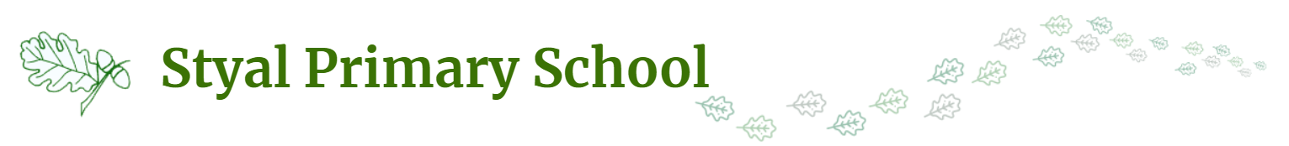

Year 3 and Year 4 Pupils- Acceptable Use Agreement
  My Learning | - I will use school devices (PCs, laptops, tablets/ iPads) for my learning.  - I will ask a teacher before using a device and ask for help if I can’t work the device.  - I will only use activities that a teacher has told or allowed me to use.  - I will ask a teacher if I am not sure what to do or I think I have done something wrong.  - I will look after the school’s computing equipment and tell a teacher if something is broken or not working properly.  - When logging on using my own username and password, I will keep it safe and secret.  - I will save only school work on the school computer and will check with my teacher before printing.  - I will log off or shut down a computer when I have finished using it.
  Using the Internet at school | - I will only visit sites that are appropriate to my learning at the time  My School Accounts  - I will keep my username and password safe and secure - I will not share it.  - I will not try to use any other person’s username and password.  - I understand that I should not write down or store a password where it is possible that someone may use it.  My role as a Digital Citizen.  - I will report any inappropriate material or messages or anything that makes me feel uncomfortable when I see it online to a trusted adult.  - I will respect other people’s work and property and will not access, copy, remove or otherwise alter any other user’s files, without the owner’s knowledge and permission.
Using the Internet at home | - I will not disclose or share personal information about myself or others when on-line (this could include names, addresses, email addresses, telephone numbers, age, gender, school details)  - I will immediately report any inappropriate material or messages or anything that makes me feel uncomfortable when I see it on-line, to a trusted adult or online agencies eg: CEOP, Childnet, Childline, Barnardos  My Communications  - I will be aware of the “SMART” rules, when I am communicating online.  - I will be polite and responsible when I communicate with others.  - I will not use inappropriate language and I understand that others may have different opinions.  My use of Social Media and Gaming  - I understand that certain sites and games have age restrictions to keep me safe.  - I understand that by accessing such sites and games, I maybe putting myself at risk of accessing inappropriate content and cyberbullying.

I understand that the school also has the right to take action against me if I am involved in incidents of inappropriate behaviour, that are covered in this agreement, when I am out of school and where they involve my membership of the school community (examples would be cyber-bullying, use of images or personal information).

I understand that these rules, help me to stay safe and I agree to follow them.
I also understand that if I break the rules I might not be allowed to use school computing equipment.
My parents/carers understand that keeping me safe on the internet at home is their responsibility.

__________________________________________
Child’s Signature

Parents / Carers:
I know that my son / daughter has signed an Acceptable Use Agreement and has received, or will receive, online safety education to help them understand the importance of safe use of technology and the internet – both in and out of school.
I understand that the school will take every reasonable precaution, including monitoring and filtering systems, to ensure that young people will be safe when they use the internet and ICT systems. I also understand that the school cannot ultimately be held responsible for the nature and content of materials accessed on the internet and using mobile technologies.
I understand that my son’s / daughter’s activity on the ICT systems will be monitored and that the school will contact me if they have concerns about any possible breaches of the Acceptable Use Policy.
I will encourage my child to adopt safe use of the internet and digital technologies at home and will inform the school if I have concerns over my child’s online safety.

________________________________ _____________________

Parent/Carer’s Signature Date

