STYAL PRIMARY SCHOOL



Positive Behaviour Policy

September 2021
To be reviewed September 2022



Aims and Expectations

We aim to:

Promote and maintain good behaviour and so support the development of honest, informed and honourable citizens of the future;

Be inclusive in our practices so all children are rewarded for following school rules and behaving well;

Recognise the many influences on children’s behaviour and take this into account when dealing with it.

It is a primary aim of our school that every member of the school community feels valued and respected and that each person is treated fairly and well. We are a caring community whose values are built on mutual trust and respect for all. The Positive Behaviour Policy is therefore designed to support the way in which all members of the school can live and work together in a supportive way. It aims to promote an environment where everyone feels happy, safe and secure.

The school has a number of school rules but the primary aim of the Positive Behaviour Policy is not a system to enforce rules but a means of promoting good relationships and positive behaviour. In this way, all people can work together with the common purpose of helping everyone to learn.

The School’s Mission Statement
Valuing the individual to believe and achieve.

Promoting Children’s Emotional Health and Wellbeing
We recognise that children’s mental health is a crucial factor in their overall wellbeing and can affect their learning and achievement. The Department for Education (DfE) recognises that: “in order to help their children succeed; schools have a role to play in supporting them to be resilient and mentally healthy”. Schools can be a place for children and young people to experience a nurturing and supportive environment that
has the potential to develop self-esteem and give positive experiences for overcoming adversity and building resilience.
This applies equally to all areas of learning and activities.

Styal Primary School aims to develop self-esteem and resilience by:
Teaching pupils skills to increase their awareness of their own emotional health and well-being and being mindful of others. Our ‘Values’ Curriculum links our key values (such as kindness) with the NHS’ 5 Steps to Wellbeing. The aim is to give children lifelong strategies to support their emotional health. The Styal values are evident and regularly revisited in assemblies and curriculum.
Creating an environment where children are respectfully monitored and feel listened to.

Positive Behaviour System
The positive behaviour system is based on five key points;

- All children have the right to learn and play, free from disruption and aggression.
- All teachers have the right to teach, free from disruption and aggression.
- Pupils who choose to follow the rules are rewarded.
- Pupils who choose to break the rules must face the consequences.
- Pupils are responsible for their own behaviour.

School Rules
The following school rules have been written by staff and pupils together and are displayed all around our school:
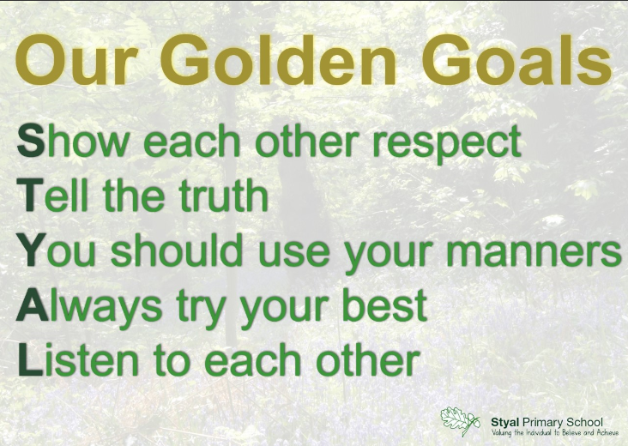

These rules are referred to regularly.

In addition, there are rules in specific areas e.g. in the classroom, the playground and the hall, to supplement the school rules. These additional rules are reviewed regularly and adapted or changed according to circumstances and the needs of children at any moment in time.

Each class teacher discusses the school rules and their own class rules with their class. In this way, every child in the school knows the standard of behaviour that we expect in our school. If there are incidents of anti-social behaviour, the class teacher discusses these with the whole class during ‘Circle Time’ or during RSE lessons.

The school expects every member of the school community to behave in a considerate way towards others.

We treat all children fairly and apply the Positive Behaviour Policy in a consistent way.

This policy aims to help children to grow in a safe and secure environment and to become positive, responsible and increasingly independent members of the school community.

The school rewards and praises good behaviour as we believe that this will develop an ethos of kindness and co-operation. This policy is designed to promote good behaviour rather than merely deter anti-social behaviour.

Rewards
We praise and reward children for good behaviour in a variety of ways:

- Teachers congratulate children e.g. with a smile, thumbs up, verbally or house points
- Teachers give children stickers for listening and behaving well
- Each week, we nominate two children from each class to be awarded a special Styal Star certificate in Friday’s Celebration Assembly. This is shared on the weekly newsletter.
- A special certificate awarded by Mrs Boardman, the headteacher, is also awarded for being a Styal Star in Friday’s Celebration Assembly. This is shared on the weekly newsletter.
- We give House Points to children either for good work or behaviour, or to acknowledge effort or acts of kindness in school. The points are added up by the House Captains each week and totalled for the half term. The winning house will be VIPs on the last Thursday before the end of each half term.
- Lunch time staff award stickers and House Points for clearing their plate and trying something new
- Class rewards are also used and result in a shared class treat. Each class has their own agreed system.
- There is a whole school Random Acts of Kindness Reward scheme in place, where children are sent to the Headteacher if they have been spotted showing a RAK (or if their friend has spotted them) and they are then able to place a ball in their class container on the display in the school hall. When a class have shown 25 RAKs, they can choose a random class reward from the ‘Thank You for Your Kindness Jar’. This is shared in the filmed assembly and on the weekly newsletter.
- Children will be sent to the Headteacher when they have done something special or when they have been spotted being kind/helpful/caring/respectful. They will get a Headteacher’s certificate, ‘Mrs Boardman thinks I am a Styal Star’ sticker or a special award such as a Styal Primary School pencil.
- The school acknowledges all the efforts and achievements of children, both in and out of school. Personal achievements are shared in class and in school assemblies. These achievements are celebrated and a picture is taken and displayed in the main school corridor on ‘The Proud Cloud’ display board.

Consequences
The school employs a number of consequences to enforce the school rules and to ensure a safe and positive learning environment. We employ each consequence systematically and fairly. These apply to Year 1 – Year 6.

The School Council have worked in conjunction with their peers, teachers and Headteacher to develop a fair system of consequences that reflect the poorer behaviours. To link with the school ‘goals’, the children developed a ‘football inspired’ system of red, double yellow and yellow cards. These relate to a staggered, graded response. The cards are metaphorical rather than a card that is physically shown.

Yellow Cards - Low Level Disruption
Low level disruption, such as speaking when the teacher is speaking or shouting out, can lead to disruption in the flow of learning.
(For a more comprehensive list, see the table below)
We aim to ensure this is understood by the children so they know it is not acceptable.
A verbal warning will be given first so children have the chance to correct their behaviour. If the behaviour is repeated, a yellow card however is awarded.
Yellow cards will be recorded in a book rather than displayed on the wall or board. The aim is to protect self-esteem.

1 yellow card = 2 minutes of playtime lost
2 yellow cards = 5 minutes of playtime lost
3 yellow cards = this then becomes a double yellow card (see below)

The children believed this is a reasonable response to poor behaviour. They want to learn. Before two yellow cards are given, a child would have been given a verbal warning, a yellow card, another verbal warning and then another yellow card. The children thought it was important that peers had chance to ‘do the right thing’ after a warning.

Double Yellow Card - Higher Level
The children strongly believed that some behaviours are completely unacceptable and unsafe. For example, shouting at an adult. They did not want children to receive a warning about this. Instead, an instant double yellow card would be given. (See the table below for further examples of the behaviours in this category).

1 double yellow card = 15 minutes of dinner time lost

A double yellow card will result in the missing of 15 minutes of dinner time. This time will be spent reflecting about the behaviour with the headteacher. This reflection time is important to understand triggers to behaviour and how this behaviour could be avoided again. This is a supportive meeting to prevent this type of behaviour. These meetings will be recorded by the headteacher. At Styal Primary School, these behaviours are unacceptable and will not have a verbal warning before it has a consequence.

Red Card – Highest Level
Behaviours such as bullying, racism, swearing and fighting are not tolerated. These will warrant a red card sanction. (see the table below for a fuller list of red card behaviours).

1 red card = 30 minutes of dinner time lost.

Reflection time will be spent with the headteacher (as above). These meetings will be recorded by the headteacher and parents informed. Like double yellow cards, these behaviours will not be tolerated and will not warrant a verbal warning before it has a consequence.

Red card  These will have no oral warning. | Fighting  Racism – and all equality issues  Throwing stones at other children on purpose  Stealing  Swearing  Bullying | Miss 30 minutes of dinner time  Eat dinner in class with their bubble.  Spend the rest of lunch with Mrs Boardman, reflecting on their behaviour.
Double yellow card  These will have no oral warning. | Play fighting  Shouting at an adult  Answering back  Saying ‘no’ to an adult | Miss 15 minutes of dinner time  Eat dinner in class with their bubble.  Spend 15 minutes of lunch with Mrs Boardman, reflecting on their behaviour.
Yellow card  These behaviours will receive one oral warning first from the adult. If the behaviour is then repeated, it will then become a yellow card. | Getting out of seat whilst the teacher is teaching at the front of the class and walking off  Name calling  Running in school or on the ramp  Pushing into the line  Shouting out in lessons – not putting hand up to speak  Talking when the teacher is talking  Damaging equipment  Pushing / shoving  Shouting in the corridor | For 1 yellow card – miss 2 minutes of playtime.  For 2 yellow cards – miss 5 minutes of playtime.  For 3 yellow cards – converted to a double yellow (see above).  This will be recorded in a book.  If the teacher sees a pattern, the teacher will put in extra support. If it still continues, the teacher will refer to Headteacher and SENDCo.

The list of behaviours above are by no means exhaustive but they are representative of the types of behaviours in each category.
Teacher and teaching assistants can give yellow and red cards. Midday Assistants will report incidents to teachers. They will not issue cards for poor behaviour.

Bullying
Styal Primary School does not tolerate bullying of any kind. If we discover that an act of bullying or intimidation has taken place, we act immediately to stop any further occurrences of such behaviour. Whilst it is very difficult to eradicate bullying, we do everything in our power to ensure that all children attend school free from fear.
At Styal Primary School our anti-bullying strategy is called Kiva. Mrs Macdonald / Mrs Boardman are the Kiva Leads and investigates incidents when a referral is made by a member of staff or parent. Kiva lessons are taught as part of our RSE curriculum.
We are involved in national initiatives such as Anti-Bullying Week that takes place every November. We take part in Odd Socks Day to recognise and celebrate our differences.

Cyber-bullying
Cyber-bullying is not tolerated at Styal. This falls under our anti-bullying strategy, Kiva. Children are explicitly taught about safeguarding and on-line safety.

Positive Handling
All members of staff are aware of the regulations regarding the use of force by teachers, as set out in DfE Circular 10/98, relating to section 550A of the Education Act 1996: The Use of Force to Control or Restrain Pupils. Staff only intervene physically to restrain children or to prevent injury to a child, or if a child is in danger of hurting themselves. These actions are in line with government guidelines on the restraint of children. Relevant staff members have been TEAM TEACH trained and work within their guidelines.

The Role of the Class Teacher
It is the responsibility of the class teacher to ensure that the school rules are enforced in their class and that their class behaves in a responsible manner during lesson time and when moving, working or playing in other areas of the school.
We have high expectations of all children in terms of behaviour and we strive to ensure that all children work to the best of their ability.
All children are treated fairly and encouraged to follow school and class rules consistently.
All children are treated with respect and understanding.
The teacher keeps a record of all yellow cards given. However, if misbehaviour continues, teachers are able to seek help and advice from the Headteacher.
Class teachers liaise with the school’s SENCO and with external agencies if necessary, to support and guide the progress of each child.
Class teachers report to parents about the progress of each child in their class, in line with whole school policy. The class teacher may also contact a parent if there are concerns about the behaviour or welfare of a child.

The Role of the Headteacher
It is the responsibility of the Headteacher, under the School Standards and Framework Act 1998, to implement the school behaviour policy consistently throughout the school and to report to governors, when requested, on the effectiveness of the policy. It is also the responsibility of the Headteacher to ensure the health, safety and welfare of all children in the school.
The Headteacher supports staff by implementing the policy, by setting the standards of behaviour and by supporting staff in the implementation of the policy.
The Headteacher keeps records of all reported serious incidents of misbehaviour.
The Headteacher has the responsibility for giving fixed-term exclusions to individual children for serious acts of misbehaviour. For repeated or very serious acts of anti-social behaviour, the Headteacher may permanently exclude a child. Both these actions are only taken after the school governors have been notified.

The Role of Parents
The school works collaboratively with parents so that children receive consistent messages about how to behave at home and at school. We explain the school rules in the school prospectus and we expect parents to read these and support them. The policy is shared on the website and parents are directed to this with updates on the school’s newsletters. We ask that the contract be signed by both parent and child and returned to school. The children are reminded of the behaviour policy as and when it is needed and the class teacher will share it with their class at the beginning of each academic year.

We expect parents to support their children’s learning and to co-operate with the school, as set out in the home – school agreement. We try to build a supportive dialogue between the home and the school and we inform parents immediately if we have concerns about their child’s welfare or behaviour.
If the school has to use reasonable sanctions to punish a child, parents should support the actions of the school. If parents have any concern about the way that their child has been treated they should initially contact the class teacher.
If the concern remains, they should contact the Headteacher. If they are still not happy, then they should contact school governors. If these discussions cannot resolve the problem, a formal grievance or appeal process can be implemented. (See Complaints Policy)

The Role of Governors
The Governing Body has the responsibility of setting down these general guidelines on standards of discipline and behaviour and of reviewing their effectiveness. The governors support the Headteacher in carrying out these guidelines.
The Headteacher has the day-to-day authority to implement the school Positive Behaviour Policy but governors may give advice to the Headteacher about particular disciplinary issues.

Fixed-term and Permanent Exclusions
Only the Headteacher has the power to exclude a pupil from school. The Headteacher may exclude a pupil for one or more fixed periods, for up to 45 days in any one school year. The Headteacher may also exclude a pupil permanently. It is also possible for the Headteacher to convert a fixed-term exclusion into a permanent exclusion if the circumstances warrant this.

An internal exclusion may be issued initially. This may be half a day or a full day. Children will work outside of the classroom and have breaks away from their peers. This is a step-up from a red card in Styal’s sanctions. The headteacher will inform the parents / carers orally but will not be put into writing. It will not be on the child’s permanent record.

If the Headteacher excludes a pupil, they must inform the parents immediately, giving reasons for the exclusion. This is put into writing in a formal letter, a copy of which is sent to East Cheshire Education Office. At the same time, the Headteacher makes it clear to the parents that they can, if they wish, appeal against the decision to the Governing Body. The school informs the parents how to make any such appeal.
The Headteacher also informs the Governing Body about any permanent exclusion and about any fixed-term exclusions beyond five days in any one term. The Governing Body itself cannot either exclude a pupil or extend the exclusion period made by the Headteacher. The Governing Body has a discipline committee which is made up of between three and five members. This committee considers any exclusion appeals on behalf of the governors.
When an appeals panel meets to consider an exclusion, they consider the circumstances in which the pupil was excluded, consider any representation by parents and the LEA, and consider whether the pupil should be reinstated. If the governors’ appeals panel decides that a pupil should be reinstated, the Headteacher must comply with this ruling.

Monitoring
The school keeps a variety of records of incidents of misbehaviour. The class teacher records lower level classroom incidents which warrant a yellow card.
The Headteacher records those incidents where a child is sent to them.
The Headteacher also keeps a record of any pupil who is excluded for a fixed-term or who is permanently excluded. It is the responsibility of the Governing Body to monitor the rate of suspensions and exclusions, and to ensure that the school policy is administered fairly and consistently.

This policy has been written in conjunction with the children, school council and staff of Styal Primary School.

Headteacher

Signed: Louise Boardman
Name: Louise Boardman, Sep 2021

Chair of Governors

Signed: Jo Hudson
Name: Jo Hudson, Sep 2021

Annex A

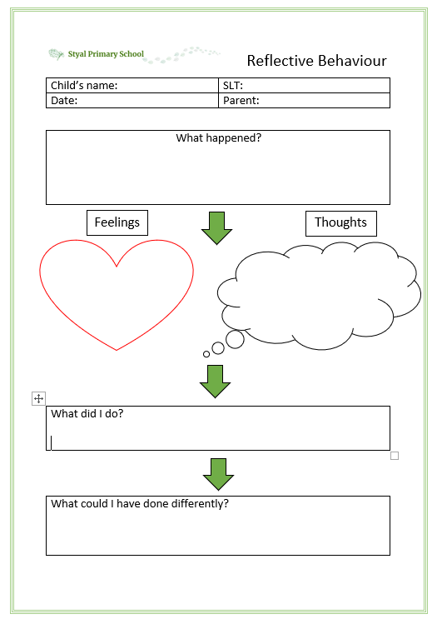

Annex B to Styal Primary School’s Positive Behaviour Policy due to Covid 19


Follow the routines for arrival and departure.
Follow the school instructions on hygiene, such as handwashing and sanitising.
Follow instructions on who you can socialise with at school.
Move around the school according to your teacher’s instructions.
Follow rules about sneezing, coughing, tissues and disposal (‘catch it, bin it, kill it’) and avoid touching your mouth, nose and eyes with your hands.
Tell an adult if you are experiencing symptoms of coronavirus.
Follow rules about NOT sharing drinking bottles.
Follow rules about breaks or play times, including where you may or may not play.
Follow the rules on use of toilets.
No coughing or spitting at or towards any other person or equipment.
Follow on-line safety rules at home.


